[angel.a.d@capgemini.com](mailto:angel.a.d@capgemini.com) / +917795209832

exitorientation.in

[15:11] D, Angel

For all your Exit queries, You may call us on the dial in number +91 80 66442727, +91 80 41834009  for any of your exit queries[Between 9:00am to 5:00pm] or write to - [exitorientation.in@capgemini.com](mailto:exitorientation.in@capgemini.com)

I reached out to my spoc hr and got this response Please call the Smart Service Desk numbers for all your Exit related queries to be answered immediately - **the dial in number : +080 66442727/+080 41834009 or write a mail to**[exitorientation.in@capgemini.com](mailto:exitorientation.in@capgemini.com)**.**

You can connect with [offboardingservices.in@capgemini.com](mailto:offboardingservices.in@capgemini.com) for all your queries post exit.

For department clearance you have to click on each department in ECMS you will get SPOC details under that, you have to get in touch with each SPOC and get the clearance completed on ECMS.

Post completion of all the departmental clearance, Once it’s completed We shall provide you final clearance and release the letters.

Full & Final settlement shall be credited in your salary account within **30 days post your final Clearance completion date**and statement will be sent to your personal email id within 5 working days post amount is credited in your account.

For PF /Gratuity related queries please drop in a mail only to & [retiralshelpdesk.in@capgemini.com](mailto:retiralshelpdesk.in@capgemini.com)

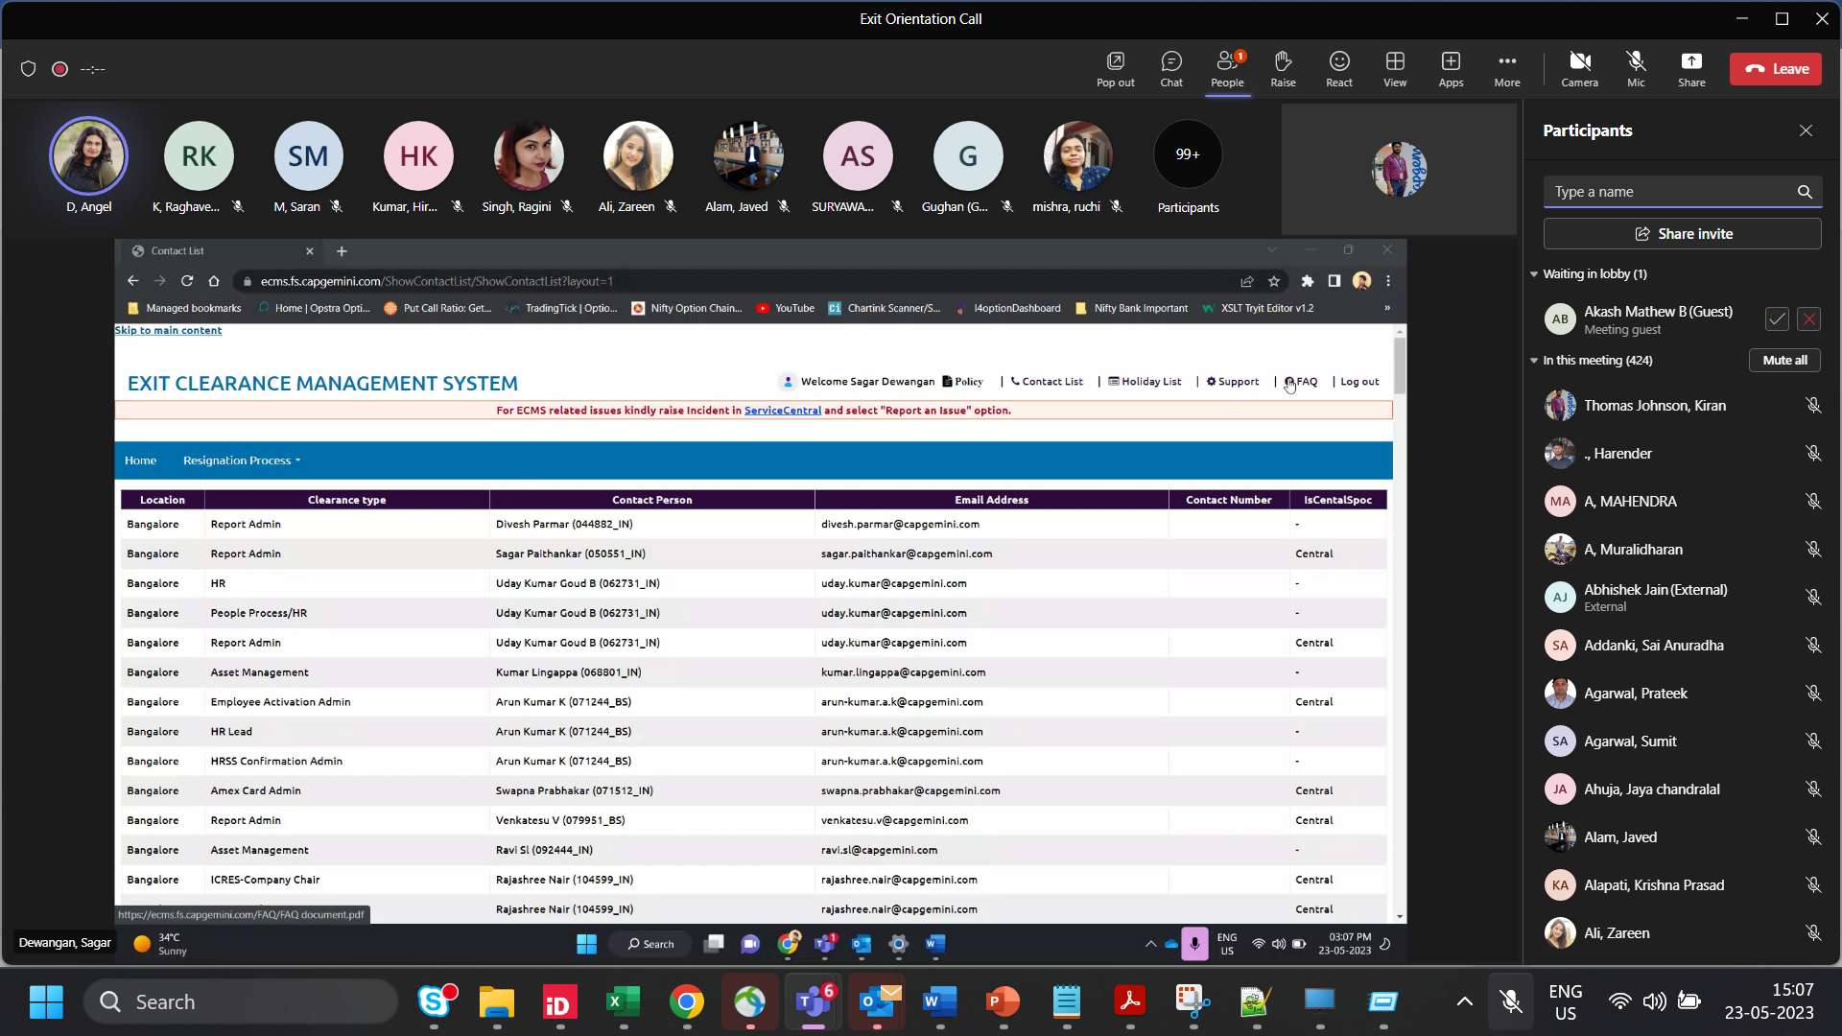

[15:13] D, Angel

Payment Screenshot : kavya.bd@capgemini.com/ tejasvi-ramesh.dhumal@capgemini.com

[rakesh.valloor@capgemini.com](mailto:rakesh.valloor@capgemini.com) = if the tax proof’s portal is not enabled (for submitting the tax proofs

HGS portal – Form 16 & Salary slips –

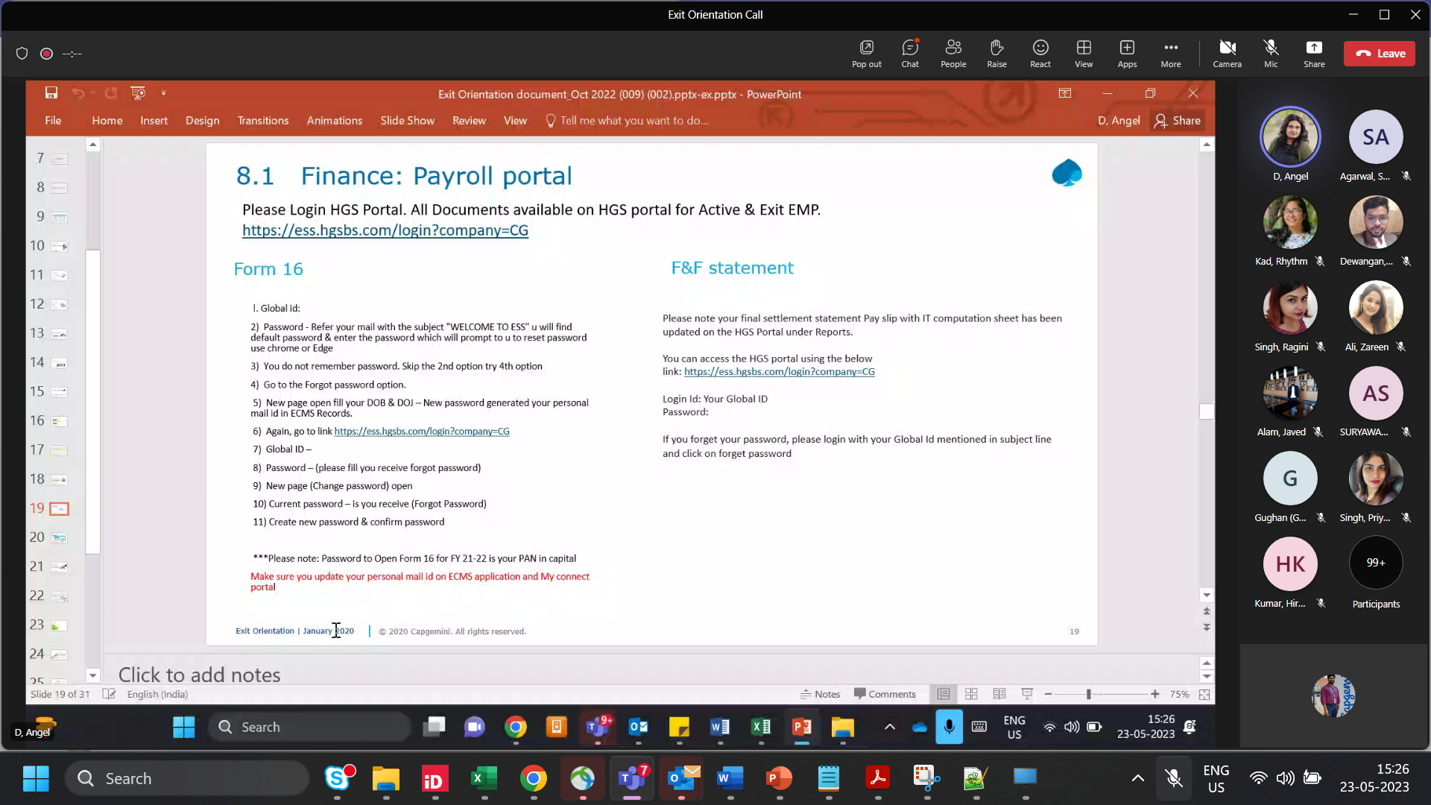

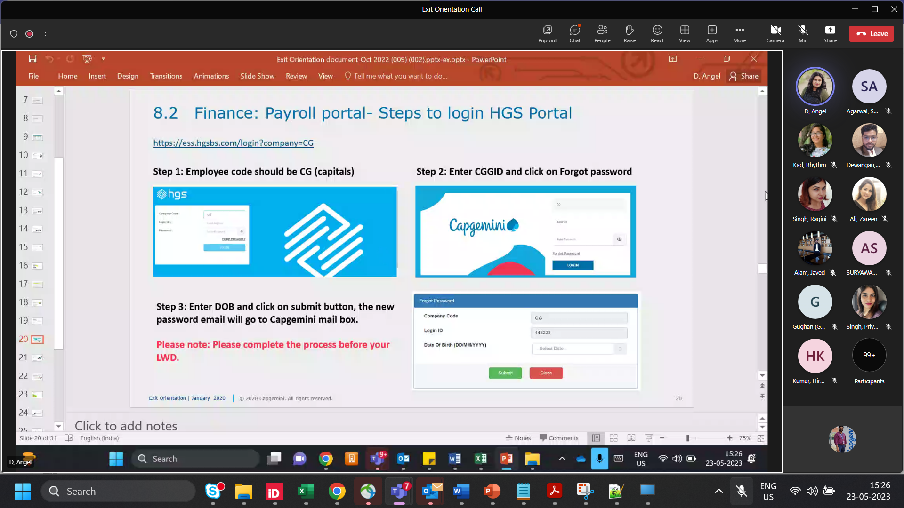

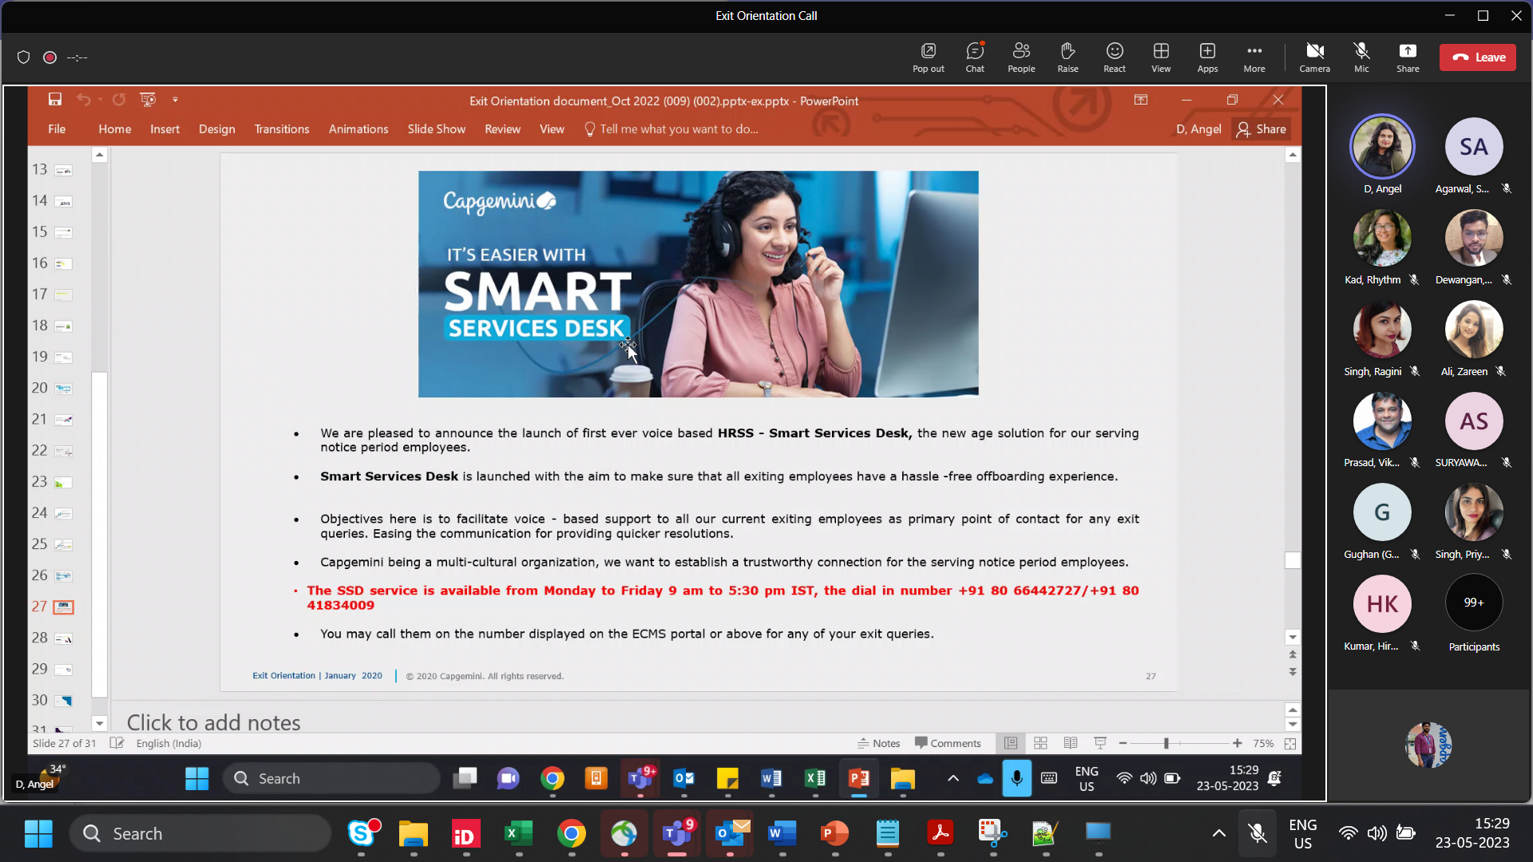

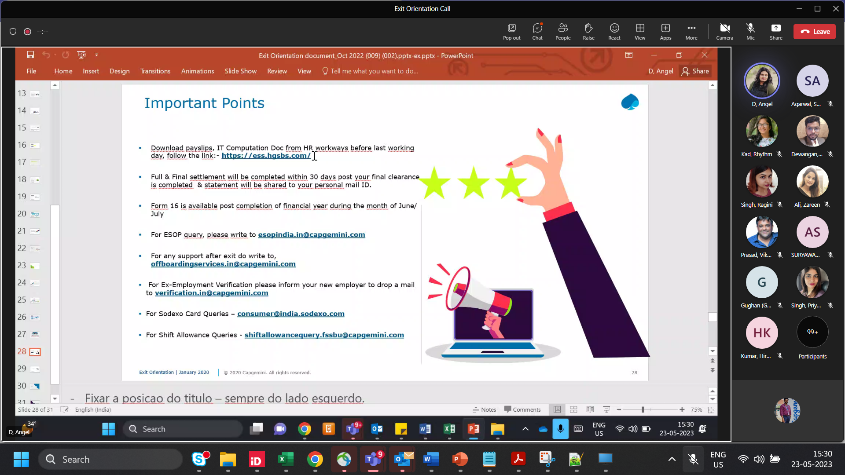

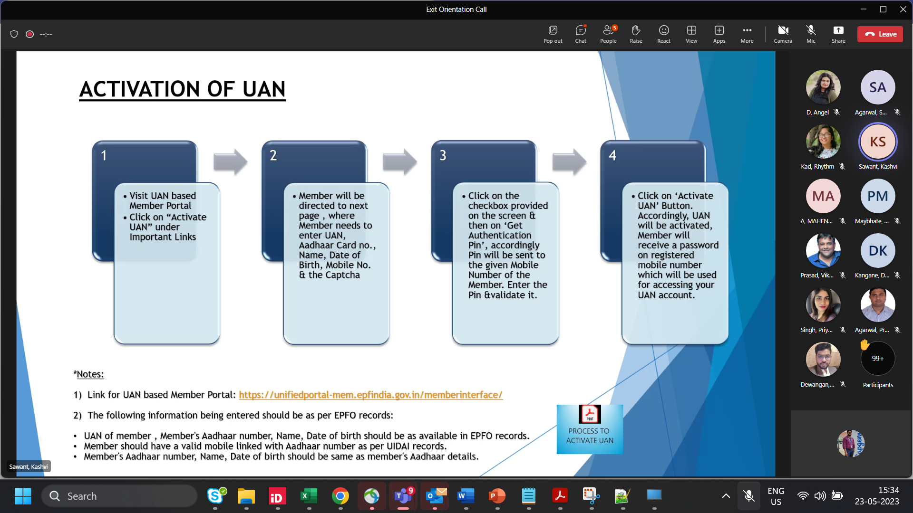

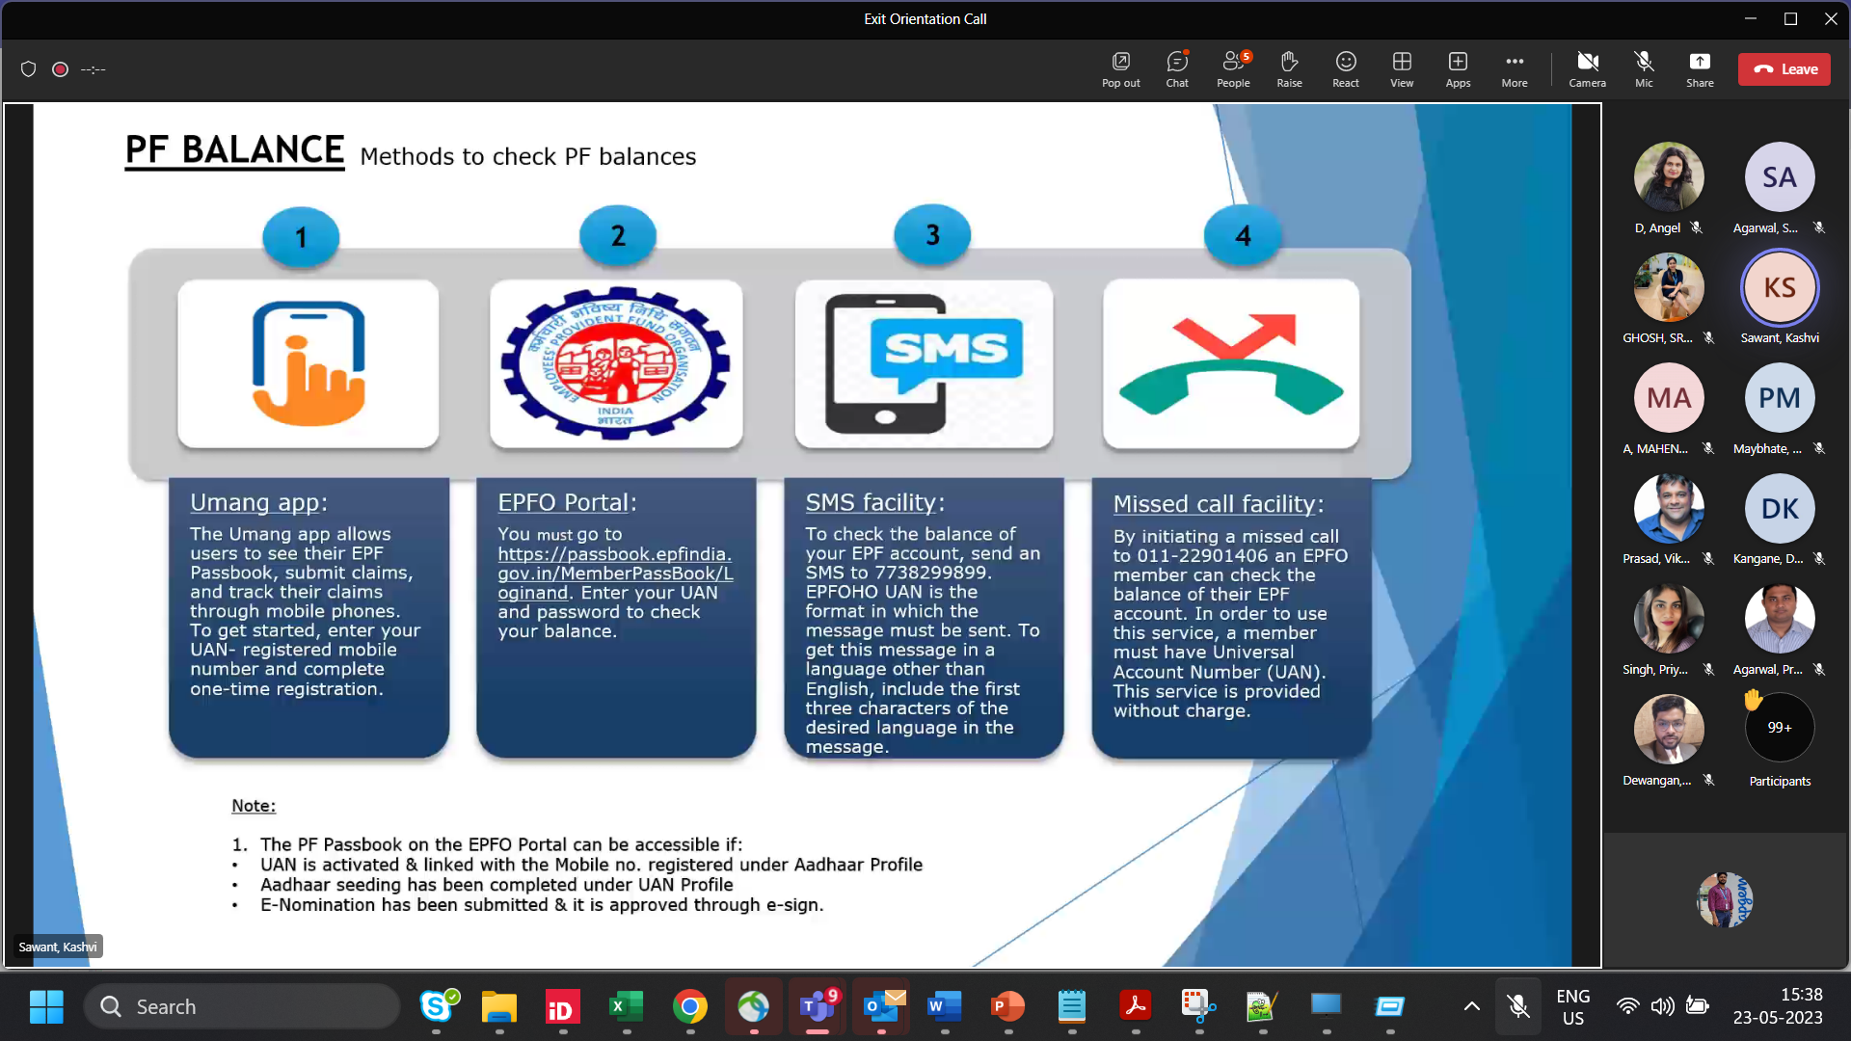

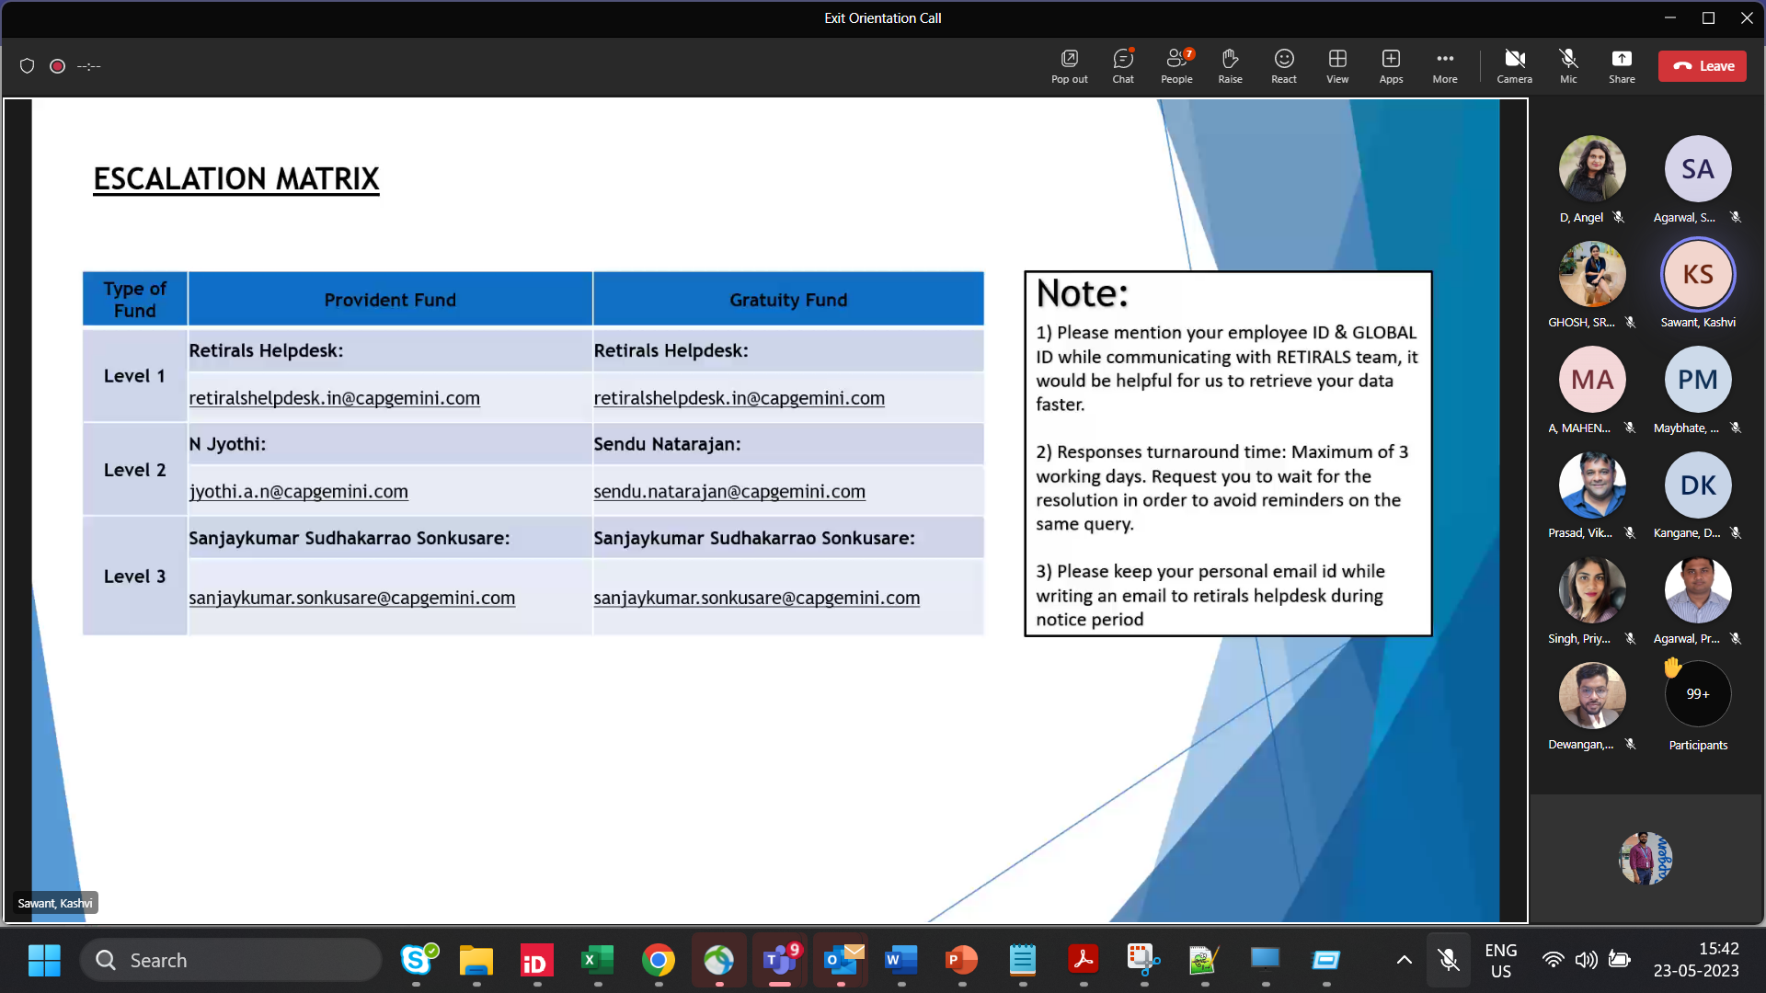

[15:46] D, Angel

**Asset Management**

**Office Drop:**

Please raise ticket in service central 3 days prior to your LWD.

You can submit the asset from where you have procured.

**Vendor pick up:**

Please raise ticket in service central 2 weeks prior to your LWD.

Please note vendor pickup TAT would be 15-20 working days to receive the asset post that only clearance will be given and FNF is processed.

Asset will be picked up only on or post your LWD.

Pickup Vendor (FLYTTA Helpdesk details):

Flytta helpdesk number on +91 8069206800 / 9866496464.

or you may send email: on [cg.wpe@goflytta.com](mailto:cg.wpe@goflytta.com)  with PC Surrender request number

Escalation SPOC :[ankush.bhor@capgemini.com](mailto:ankush.bhor@capgemini.com)

**EIS/HR clearance**

EIS/HR clearance will be auto approved 2 days prior to your LWD no follow up is required.

**Supervisor Clearance:**

Please ask your supervisor to approve your time sheets from last 6 months till your LWD and provide supervisor clearance in ECMS.

Approve the shift/on call allowance.

**Finance clearance:**

Finance clearance will be given 2 days prior to your LWD.

Just in case if you do not get the clearance please connect with myself or the exit team to take it forward.

Escalation SPOC: ganesh.a.s@capgemini.com

**People process clearance:**

People process clearance will be auto-approved on or before your LWD.

**Time help desk clearance:**

Time help desk clearance will be auto approved once all your time sheets form last 6 months till your LWD approved.

For any queries related to Time sheet and clarity : Timesheet/Clarity- timehelpdeskteam.fssbu@capgemini.com ; [empulse_support.in@capgemini.com](mailto:empulse_support.in@capgemini.com)

IN, Time Helpdesk team [timehelpdeskteam.in@capgemini.com](mailto:timehelpdeskteam.in@capgemini.com) for NON FS Resources

**BU HR clearance:**

Please follow up with your BU HR for the clearance.

Just in case if you do not get the clearance please connect with myself or the exit team to take it forward.

**ICRES clearance:**

ICRES clearance will be given on your LWD post submission of your ID card and access card. If in case, you have joined virtually team will provide the clearance by LWD.

**Leaves:**

Leaves during notice period: There is no defined policy, however it is at the discreeting of your reporting supervisor or manager to approve them in connection with the BUHR

Leave encashment: Maximum 30 leaves get encashed with your F&F and is calculated on TBC (Total base component) of your CTC.

**Insurance:**

Any queries related to Insurance please reach out to the teamIN, Employee Insurance <[employeeinsurance.in@capgemini.com](mailto:employeeinsurance.in@capgemini.com)>

**Salary**:

For the employees whose LWD is before 5*th* of that month then previous month salary will be on hold and will be part of FNF.

For employees whose LWD is after 5*th* then the previous month salary will be released

If there is no reply from retiral helpdesk for more than 36hrs (3days), please reach out to Acharekar, Pranali Shashikant <pranali-shashikant.acharekar@capgemini.com>; V, Mahendra <mahendra.v@capgemini.com> for PF & gratuity queries.

For form 16 please connect with : CGfnf <cgfnf@hgsbs.com/ cgpayroll@hgsbs.com, in case you do not receive a reply from the HGS team please connect with the payroll team on the mentioned email ids: ganesh.a.s@capgemini.com

**In house Team:**

Any support required for Supervisor clearance – Nayak, Sowmya [sowmya.nayak@capgemini.com](mailto:sowmya.nayak@capgemini.com)

Final clearance - S, ARUNKUMAR <arunkumar.d.s@capgemini.com>/BD, Kavya [kavya.bd@capgemini.com](mailto:kavya.bd@capgemini.com)

Letters: shweta.john@capgemini.com/tejasvi-ramesh.dhumal@capgemini.com/Amin, Shreyas Ramesh <shreyas.amin@capgemini.com>

star 1

[15:47] D, Angel

PF/Gratuity/Retirals- [retiralshelpdesk.in@capgemini.com](mailto:retiralshelpdesk.in@capgemini.com) **,**

Offboarding formalities-[offboardingservices.in@capgemini.com](mailto:offboardingservices.in@capgemini.com)

Payroll- [inpayroll.fssbu@capgemini.com](mailto:inpayroll.fssbu@capgemini.com) ; CGfnf <[cgfnf@hgsbs.com](mailto:cgfnf@hgsbs.com)>

C&B- [compensationreview.fssbu@capgemini.com](mailto:compensationreview.fssbu@capgemini.com)

Shift Allowance- [shiftallowancequery.fssbu@capgemini.com](mailto:shiftallowancequery.fssbu@capgemini.com),Khadanga, Swetlana <manjunatha.b-v@capgemini.com> [padmavati.kirtikumar-mistry@capgemini.com](mailto:padmavati.kirtikumar-mistry@capgemini.com)

Exit/Relieving Letter- [centralexit.in@capgemini.com](mailto:centralexit.in@capgemini.com)

F&F- [fnfhelpdesk.in@capgemini.com](mailto:fnfhelpdesk.in@capgemini.com)

Time sheet/Empulse- [timehelpdeskteam.fssbu@capgemini.com](mailto:timehelpdeskteam.fssbu@capgemini.com) ; [empulse_support.in@capgemini.com](mailto:empulse_support.in@capgemini.com)

Supervisor Change/HR Systems- [hrssedm.in@capgemini.com](mailto:hrssedm.in@capgemini.com)

IT Help- [ithelp.global@capgemini.com](mailto:ithelp.global@capgemini.com)

Leave/LMS- [hrssams.ig@capgemini.com](mailto:hrssams.ig@capgemini.com)

Employee Insurance- [employeeinsurance.in@capgemini.com](mailto:employeeinsurance.in@capgemini.com)

MediBuddy- [capgemini@mediassist.in](mailto:capgemini@mediassist.in)

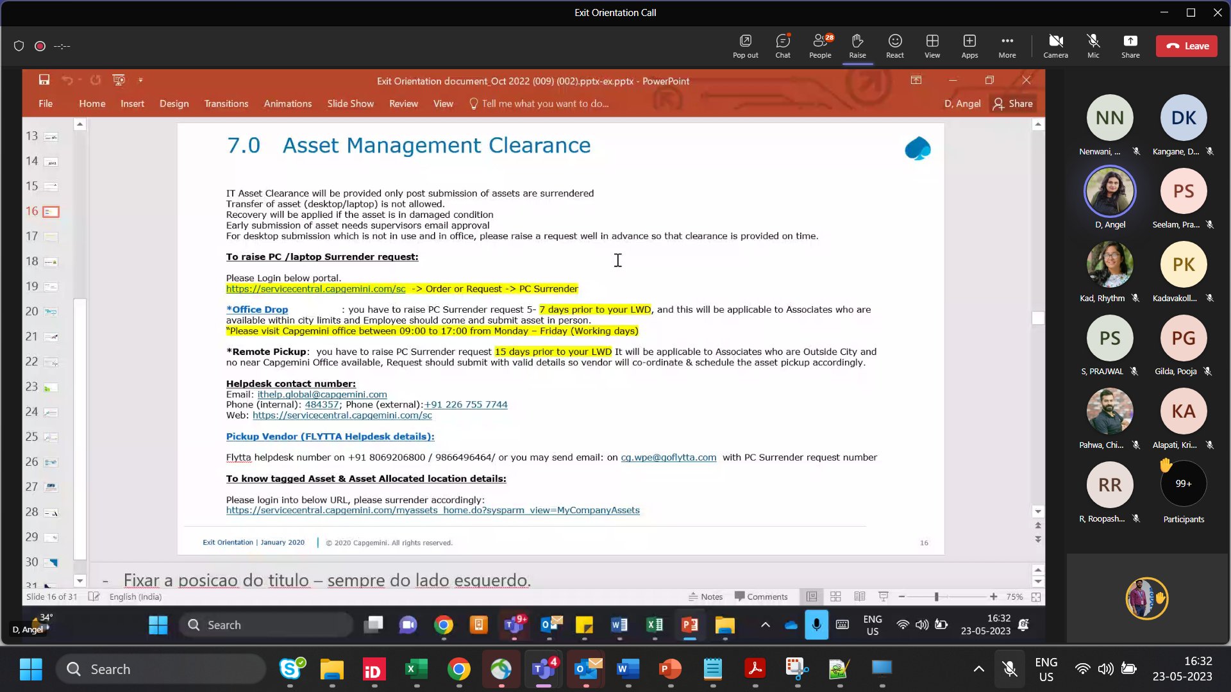

Asset related query - [ankush.bhor@capgemini.com](mailto:ankush.bhor@capgemini.com)

[16:38] Bhor, Ankush

Link to check allocated assets  
<https://servicecentral.capgemini.com/myassets_home.do?sysparm_view=MyCompanyAssets>

star 1

ServiceNow

[15:38] D, Angel

PF/Gratuity/Retirals- [retiralshelpdesk.in@capgemini.com](mailto:retiralshelpdesk.in@capgemini.com) **,**

Offboarding formalities-[offboardingservices.in@capgemini.com](mailto:offboardingservices.in@capgemini.com)

Payroll- [inpayroll.fssbu@capgemini.com](mailto:inpayroll.fssbu@capgemini.com) ; CGfnf <[cgfnf@hgsbs.com](mailto:cgfnf@hgsbs.com)>

C&B- [compensationreview.fssbu@capgemini.com](mailto:compensationreview.fssbu@capgemini.com)

Shift Allowance- [shiftallowancequery.fssbu@capgemini.com](mailto:shiftallowancequery.fssbu@capgemini.com),Khadanga,

Exit/Relieving Letter- [centralexit.in@capgemini.com](mailto:centralexit.in@capgemini.com)

F&F- [fnfhelpdesk.in@capgemini.com](mailto:fnfhelpdesk.in@capgemini.com)

Time sheet/Empulse- [timehelpdeskteam.fssbu@capgemini.com](mailto:timehelpdeskteam.fssbu@capgemini.com) ;

Supervisor Change/HR Systems- [hrssedm.in@capgemini.com](mailto:hrssedm.in@capgemini.com)

IT Help- [ithelp.global@capgemini.com](mailto:ithelp.global@capgemini.com)

Leave/LMS- [hrssams.ig@capgemini.com](mailto:hrssams.ig@capgemini.com)

Employee Insurance- [employeeinsurance.in@capgemini.com](mailto:employeeinsurance.in@capgemini.com)

MediBuddy- [capgemini@mediassist.in](mailto:capgemini@mediassist.in)

star 1

